EXPT NO: 6Implemention of Ensemble Techniques (Bagging, Boosting, Random Forest, Stacking)and Handling Class Imbalance (SMOTE)

SCENARIO 1 – (Bagging)
Problem Statement
Predict whether a patient has diabetes.
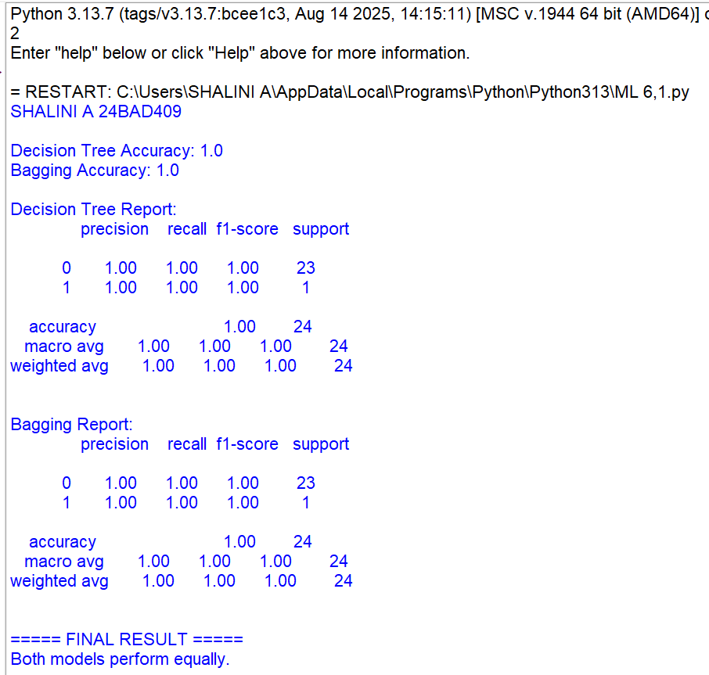
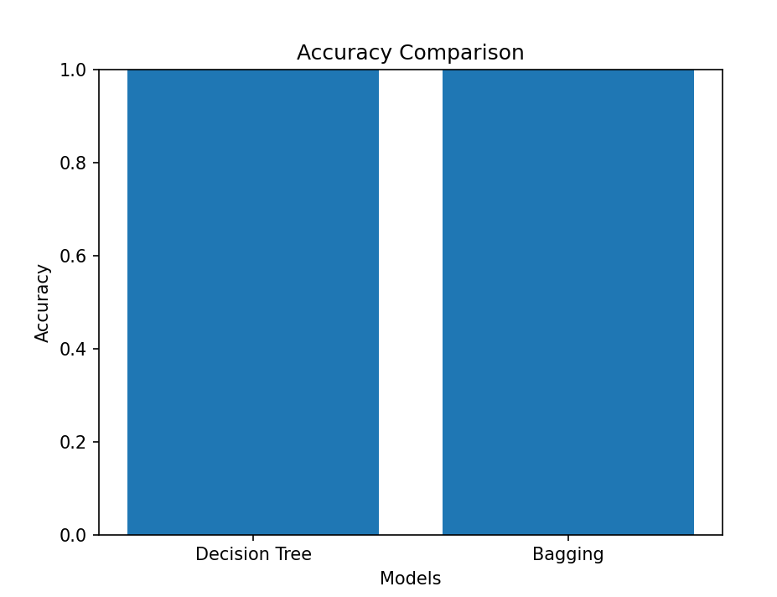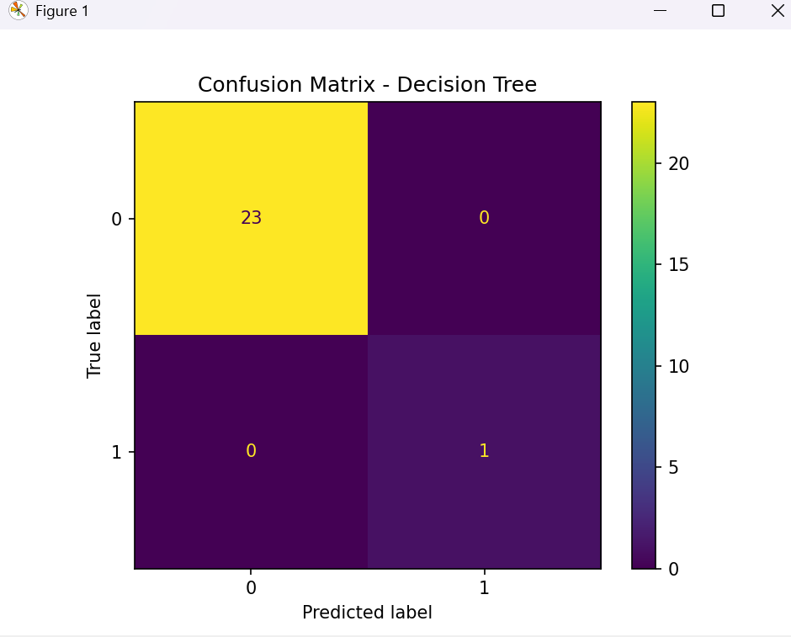

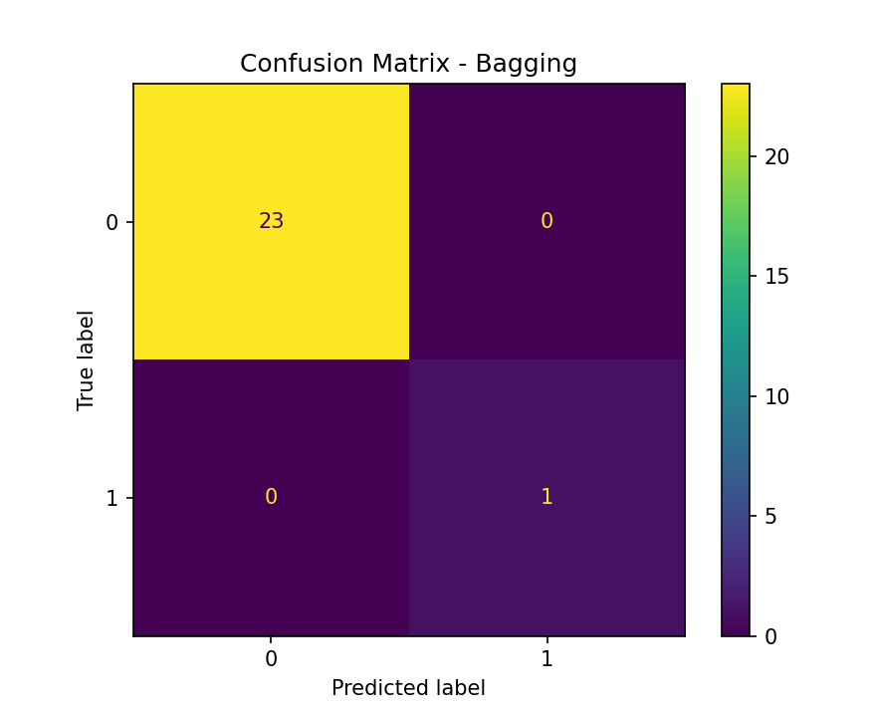

SCENARIO 2 – (Boosting-AdaBoost,Gradient Boosting)
Problem Statement
Predict whether a customer will churn.
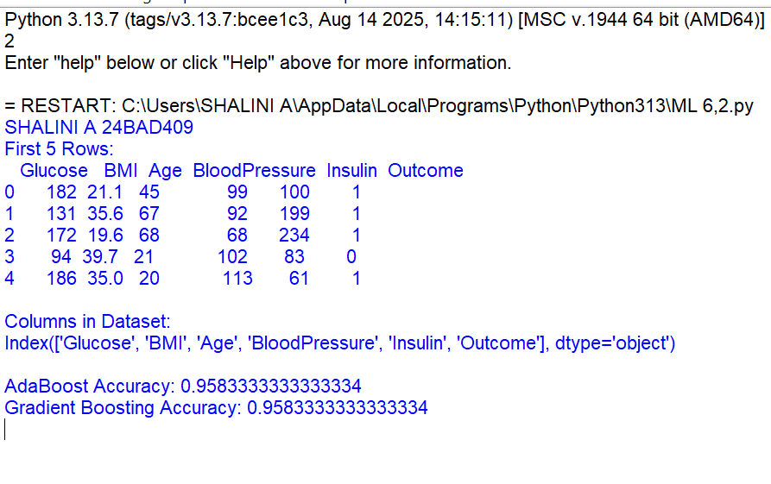
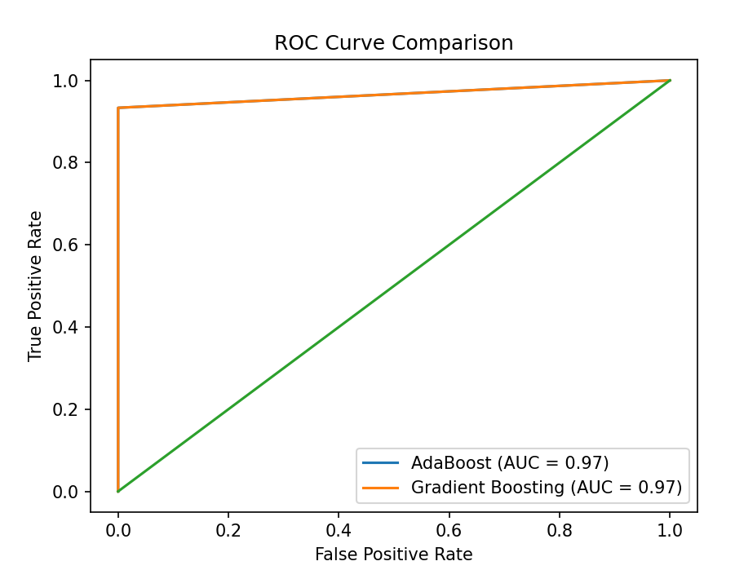
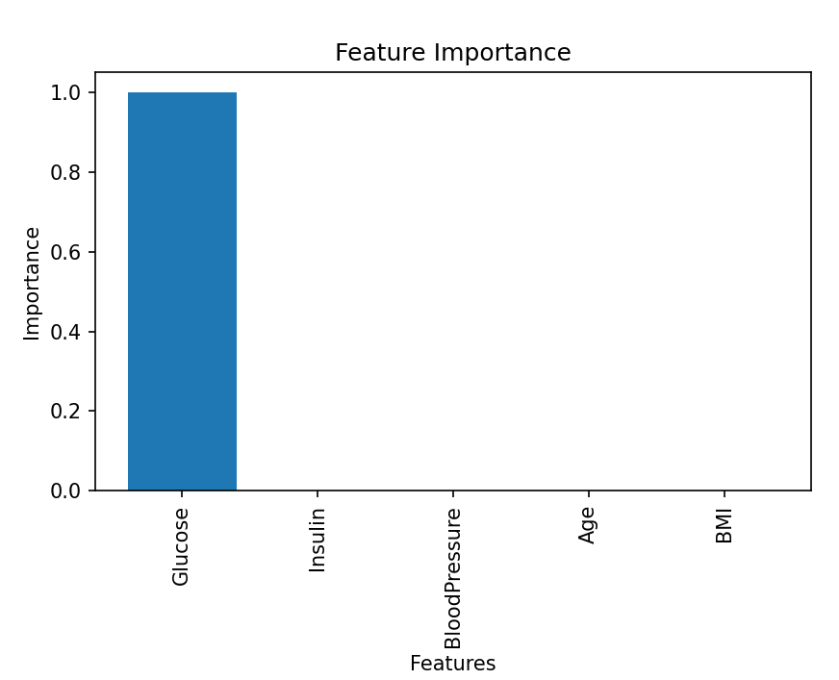
SCENARIO 3 – Random Forest
Problem Statement
Predict whether a person earns >50K salary.
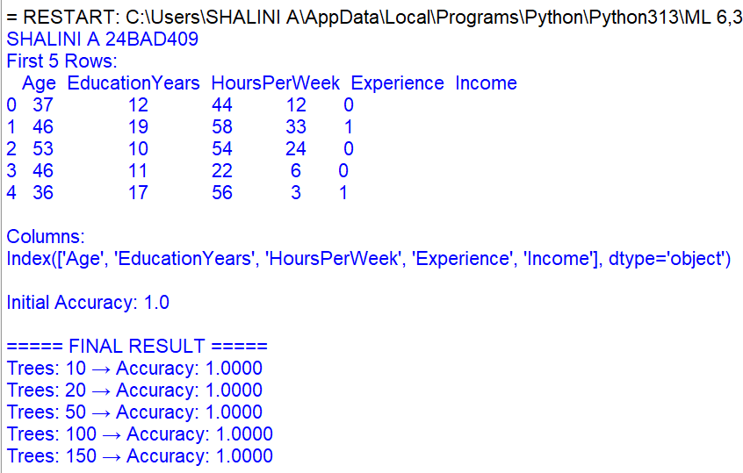
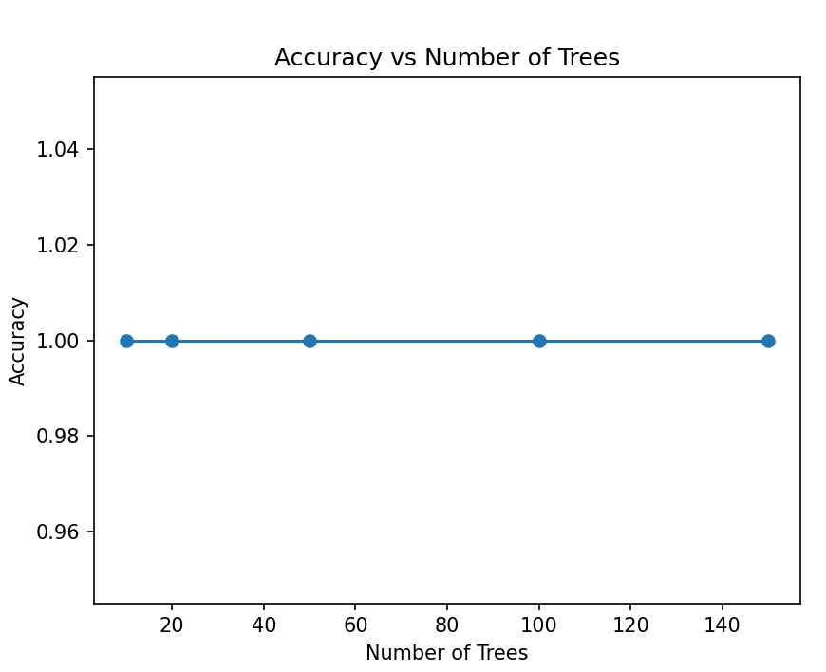
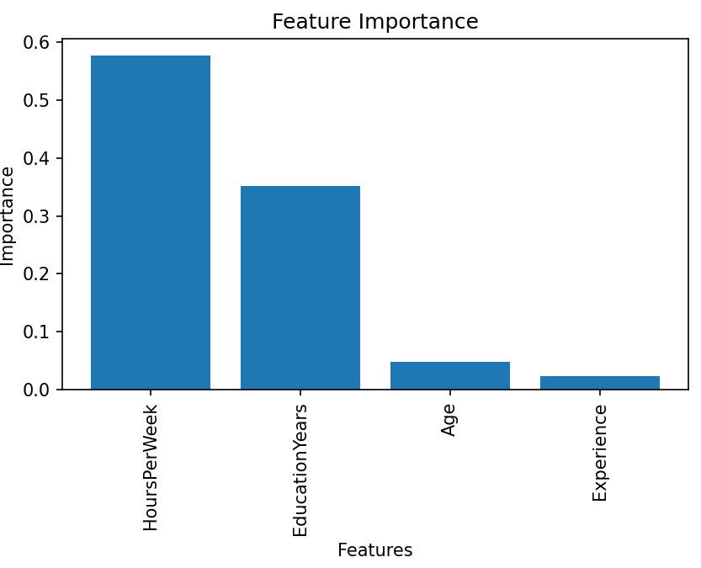
SCENARIO 4 – Stacking
Problem Statement
Predict heart disease presence.
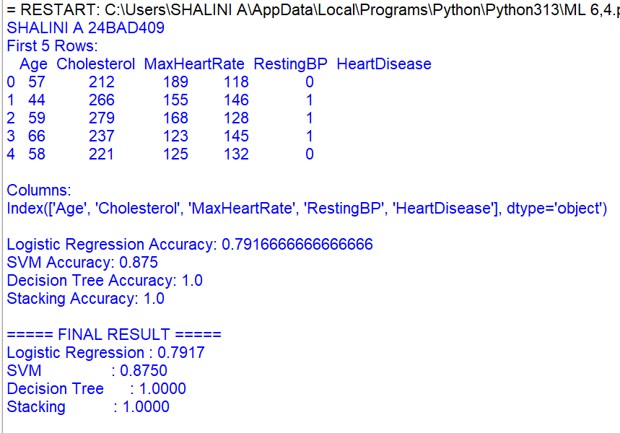
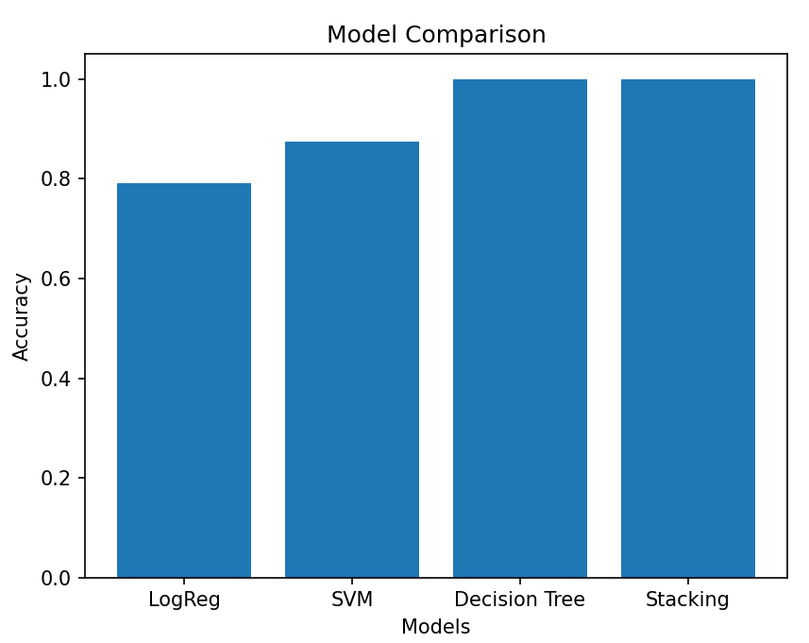

SCENARIO 5 – SMOTE
Problem Statement
Detect fraudulent transactions. 